April 2021 | Education
 | 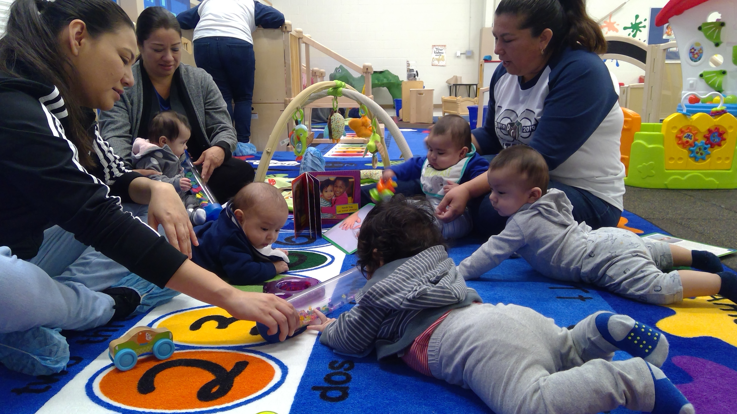
Sunday | Monday | Tuesday | Wednesday | Thursday | Friday | Saturday
 |  |  |  | 1 | 2 | 3
4 | 5 | 6 | 7 | 8 | 9 | 10
11 | 12 | 13 | 14 | 15 | 16 | 17
 | Frog Street Infants  Classroom Observation for Curriculum Fidelity  Training  - General Guidelines:  - Teacher’s Sensitivity to Social and Emotional Needs of Children  - Instructional Strategies Implemented by Developmental Domains  - Classroom Environment  - Intentionality | Frog Street Toddlers  Classroom Observation for Curriculum Fidelity  Training  - General Guidelines:  - Teacher’s Sensitivity to Social and Emotional Needs of Children  - Instructional Strategies Implemented Individually or in Small Groups  - Classroom Environment  - Intentionality | Frog Street Threes  Classroom Observation for Curriculum Fidelity  Training  - General Guidelines:  - Teacher’s Sensitivity to Social and Emotional Needs of Children  - Instructional Strategies Implemented in Whole Group, Small Group and Centers  - Classroom Environment  - Learning Centers
18 | 19 | 20 | 21 | 22 | 23 | 24
 | Curriculum Fidelity Observations | Curriculum Fidelity Observations | Curriculum Fidelity Observations | Curriculum Fidelity Observations | Curriculum Fidelity Observations
25 | 26 | 27 | 28 | 29 | 30
 | Curriculum Fidelity Observations | Curriculum Fidelity Observations | Curriculum Fidelity Observations | Curriculum Fidelity Observations | Curriculum Fidelity Observations

